**Expression levels of WNTs in breast cancer**

|  |  |
| --- | --- |
|  |  |
|  |  |
|  |  |
|  |  |
|  |  |
|  |  |

**The survival analysis of WNTs between normal tissues and tumor tissues**

|  |  |
| --- | --- |
| WNT2 | WNT2B |
| WNT3 | WNT5A |
| WNT5B | WNT6 |

|  |  |
| --- | --- |
| WNT7**B** | WNT9A |
| WNT9B | WNT10A |
| WNT10B | WNT11 |

**Mutation characteristics of WNTs in breast cancer**

The frequency of alteration showing mutations (green), amplification (red), deep deletion (blue), and multiple alterations (gray) was presented graphically. Datasets having a minimum of 100 cases were plotted.

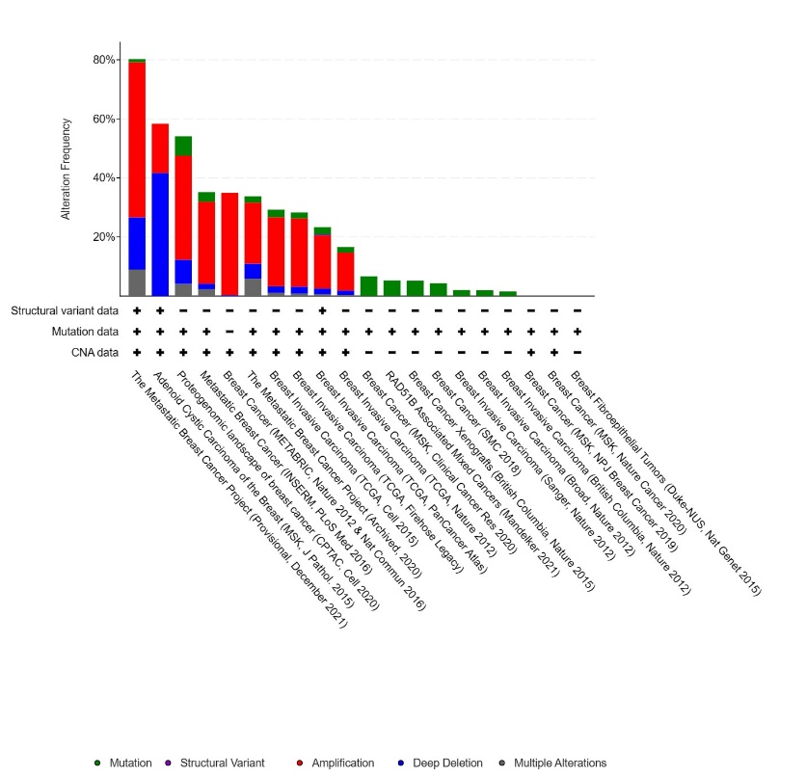

**mRNA expression pattern of WNTs in breast cancer patients**

The expression pattern of CDKs in BC was examined using UCSC XENA. Heat map displaying the expression patterns of WNTs. XENA was used to extract WNT expression. Comparing expression of WNTs amongst GTEx (normal breast, n= 179), Solid Tissue Normal (tissue surrounding the tumor (n=113), and primary tumor (cancer, n=1092).

primary site sample type

WNT2

WNT1, WNT2, WNT2B, WNT3, WNT3A, WNT4, WNT5A, WNT5B, WNT6, WNT7A, WNT7B, WNT8A, WNT8B, WNT9A, WNT9B, WNT10A, WNT10B, WNT11, WNT16

**Expression pattern of WNTs in Breast cancer**

Box Plots of the expression pattern of CDKs analyzed using TCGA BRCA and GTEx datasets using UCSC XENA.

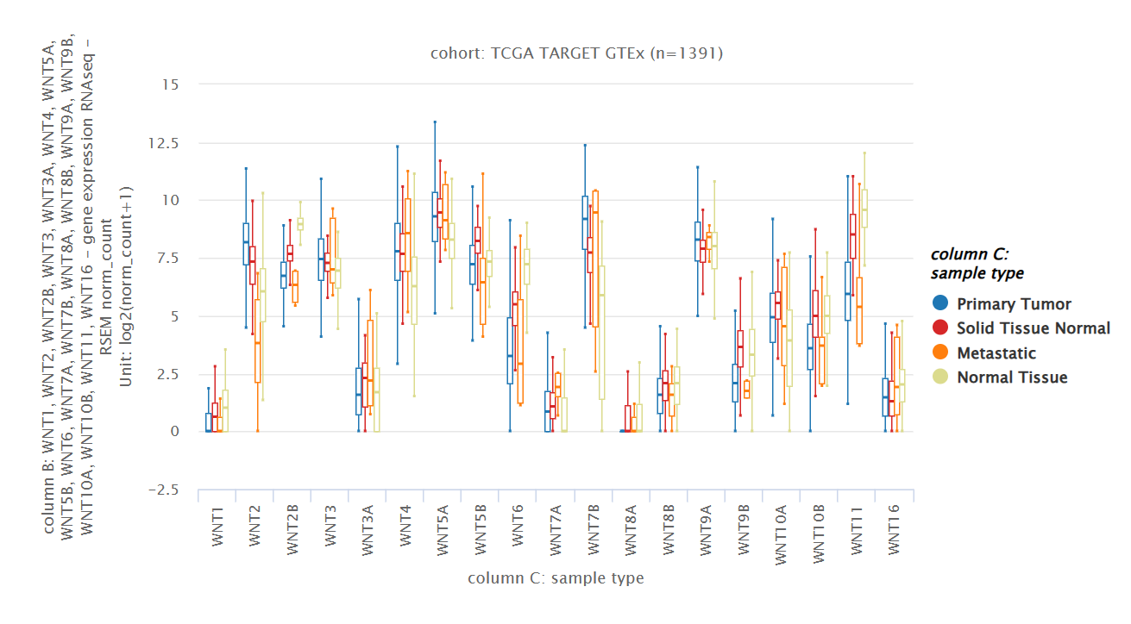

**Gene mutations**

**WNT2**

19 Mutations: includes 6 duplicate mutations in patients with multiple samples

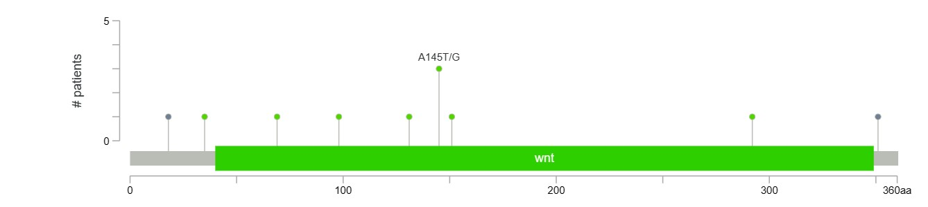

**WNT6**

12 Mutations: includes 5 duplicate mutations in patients with multiple samples

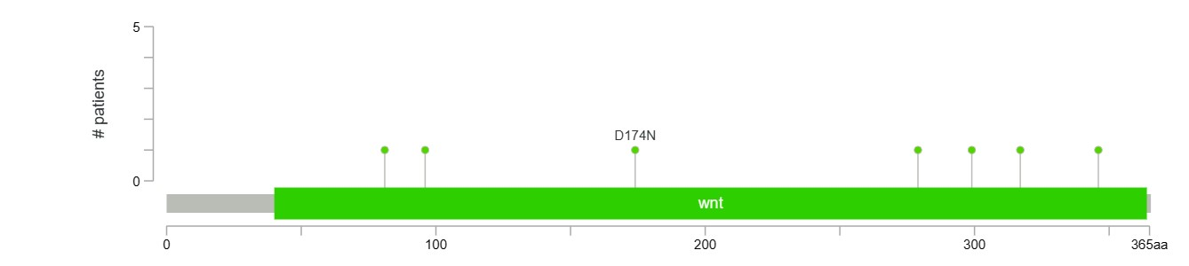

**WNT7B**

9 Mutations: includes 1 duplicate mutation in patients with multiple samples

**WNT11**

8 Mutations: includes 1 duplicate mutation in patients with multiple samples

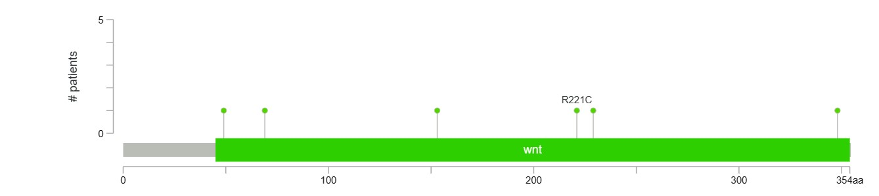

**Correlation between gene expression and immune cells infiltration**

WNT2

WNT1, WNT2, WNT2B, WNT3, WNT3A, WNT4, WNT5A, WNT5B, WNT6, WNT7A, WNT7B, WNT8A, WNT8B, WNT9A, WNT9B, WNT10A, WNT10B, WNT11, WNT16

|  |  |
| --- | --- |
|  | WNT2B |
| WNT3 | WNT5A |
|  |  |
| WNT5B | WNT6 |

WNT7B

|  |  |
| --- | --- |
|  | WNT9A |
| WNT9B |  |
|  | WNT11 |

**Gene Outcome Analysis**

